**WORKING WITH S3 AND SETTING PERMISSIONS**

**Steps:**

1. **Logon on to console and click on s3**
2. **Click on create bucket enter bucket name bucketalb and select region MUMBAI and click create**
3. **Upload a audio file and right click on it click on public and select properties**
4. **Copy paste the URL on the browser to access the uploaded file**

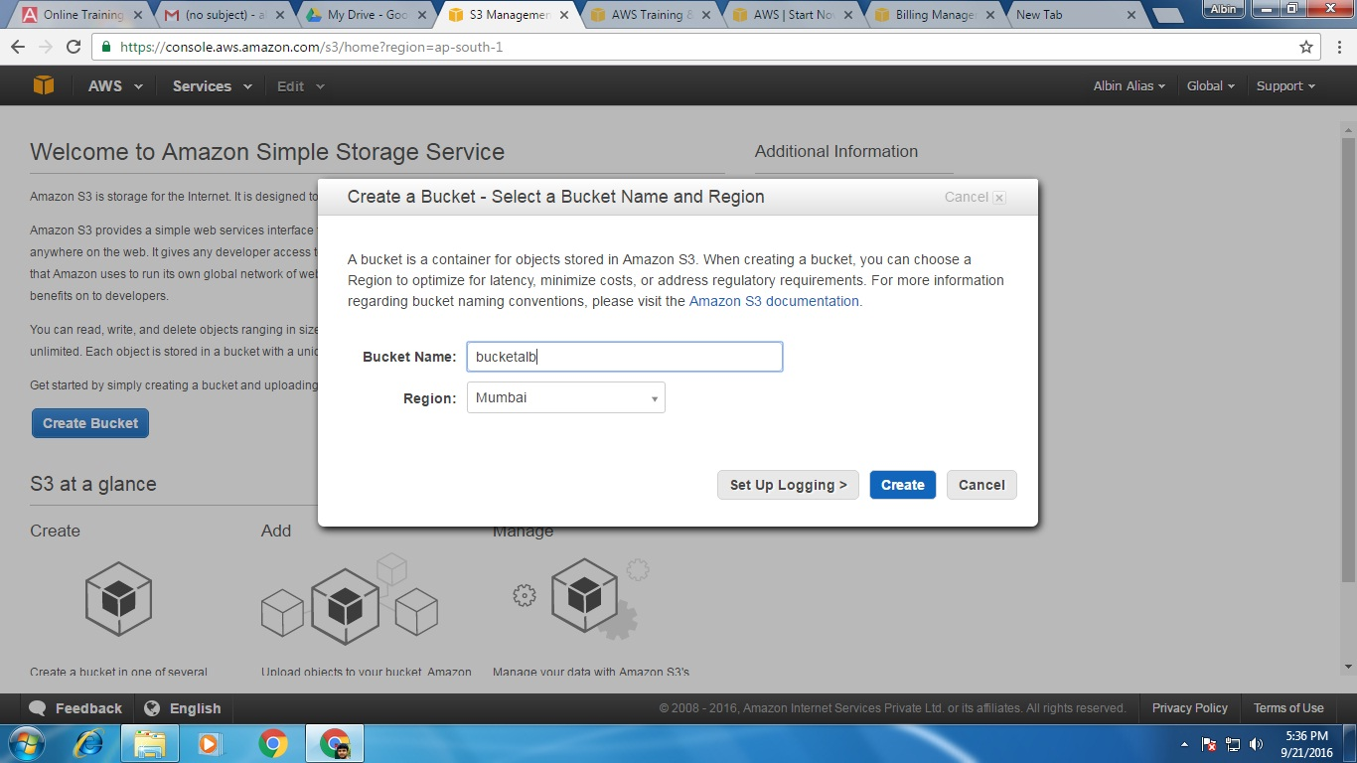

**5. Similarly upload a dps.html file to the bucket bucketalb**

**6. goto bucketalb>properties >static website hosting>enable web site hosting give the index name as dps.html**

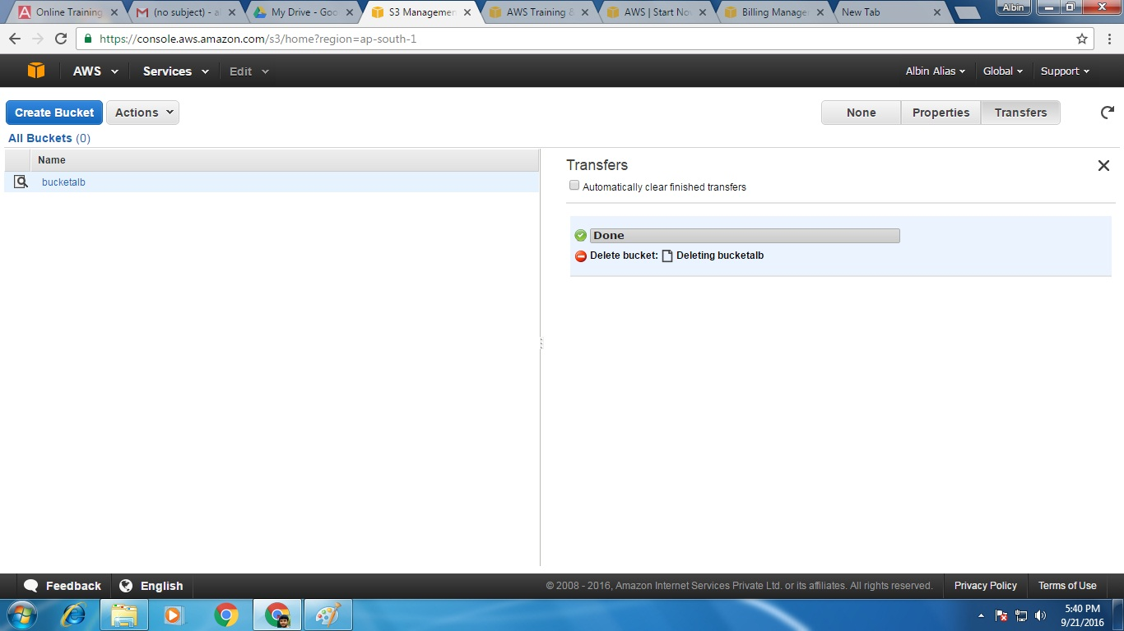

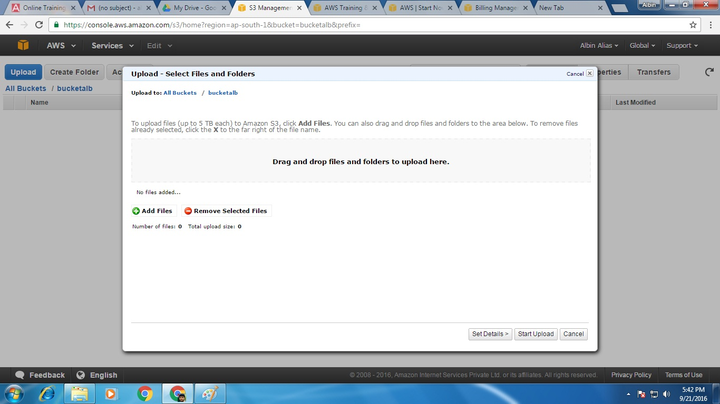

**7. bucketalb>bucket policy>aws policy generator**

**8. effect >allow and aws policy>s3 bucket policy**

**9. principal>* and actions>all**

**10. ARN>arn:aws:s3:::bucketalb**

**11. click on save two times**

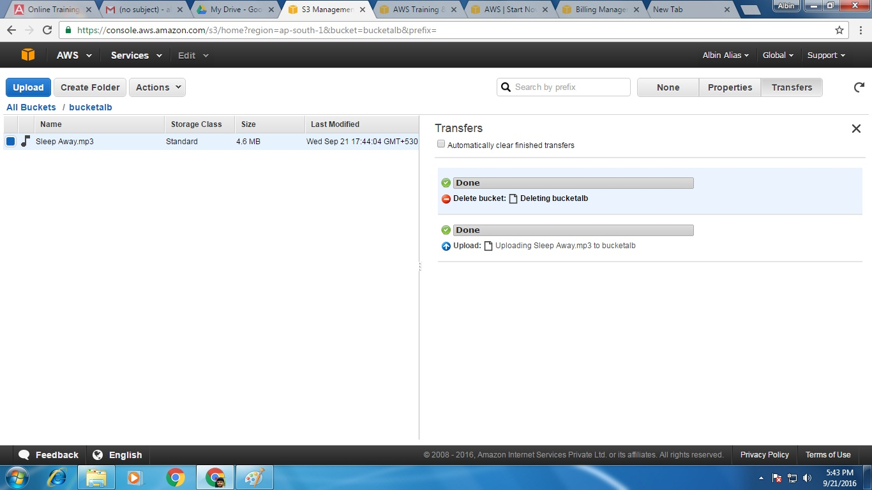

**12.Right click on bucketalb>properties> add more permissions>everyone>save**

**13. Right click on dps.html>properties> add more permissions>everyone>save**

**14.dps.html >copy paste the URL on the right top to access the static web page as below**

